Features of Spread Sheet

Support complex calculations and formulas

Customize the type of data stored in cells

Accept different data types such as

Number

Text /String

Expressions, formulas and references

Main concepts:

Director

Element

Cell

SpreadSheet

Content

TextCell

NumberCell

Reference

Concept Relationship

We have the following concept relationships among our classes:

Generalization (Inheritance)

Composition

Aggregation

Design patterns

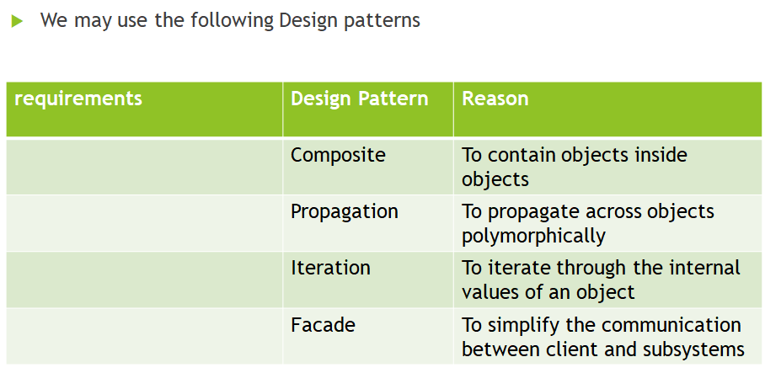

Sprints

|  |  |
| --- | --- |
| Sprint 1 | Element  Cell  Spreadsheet  Content  Director  TextCell |
| Sprint 2 | NumberlCell  ReferenceCell |
| Sprint 3 |  |
| Sprint 4 | Implement the mathematical operations:  Add()  Subtract()  Multiply()  Division() |
| Sprint 5 | Implementing setCell() |
| Sprint 6 | Parse cell syntax (formula) |
| Sprint 7 | -Parse cell’s square brackets  -parse references to cell |
| Sprint 8 | Deal with parathensis |

UML Diagram

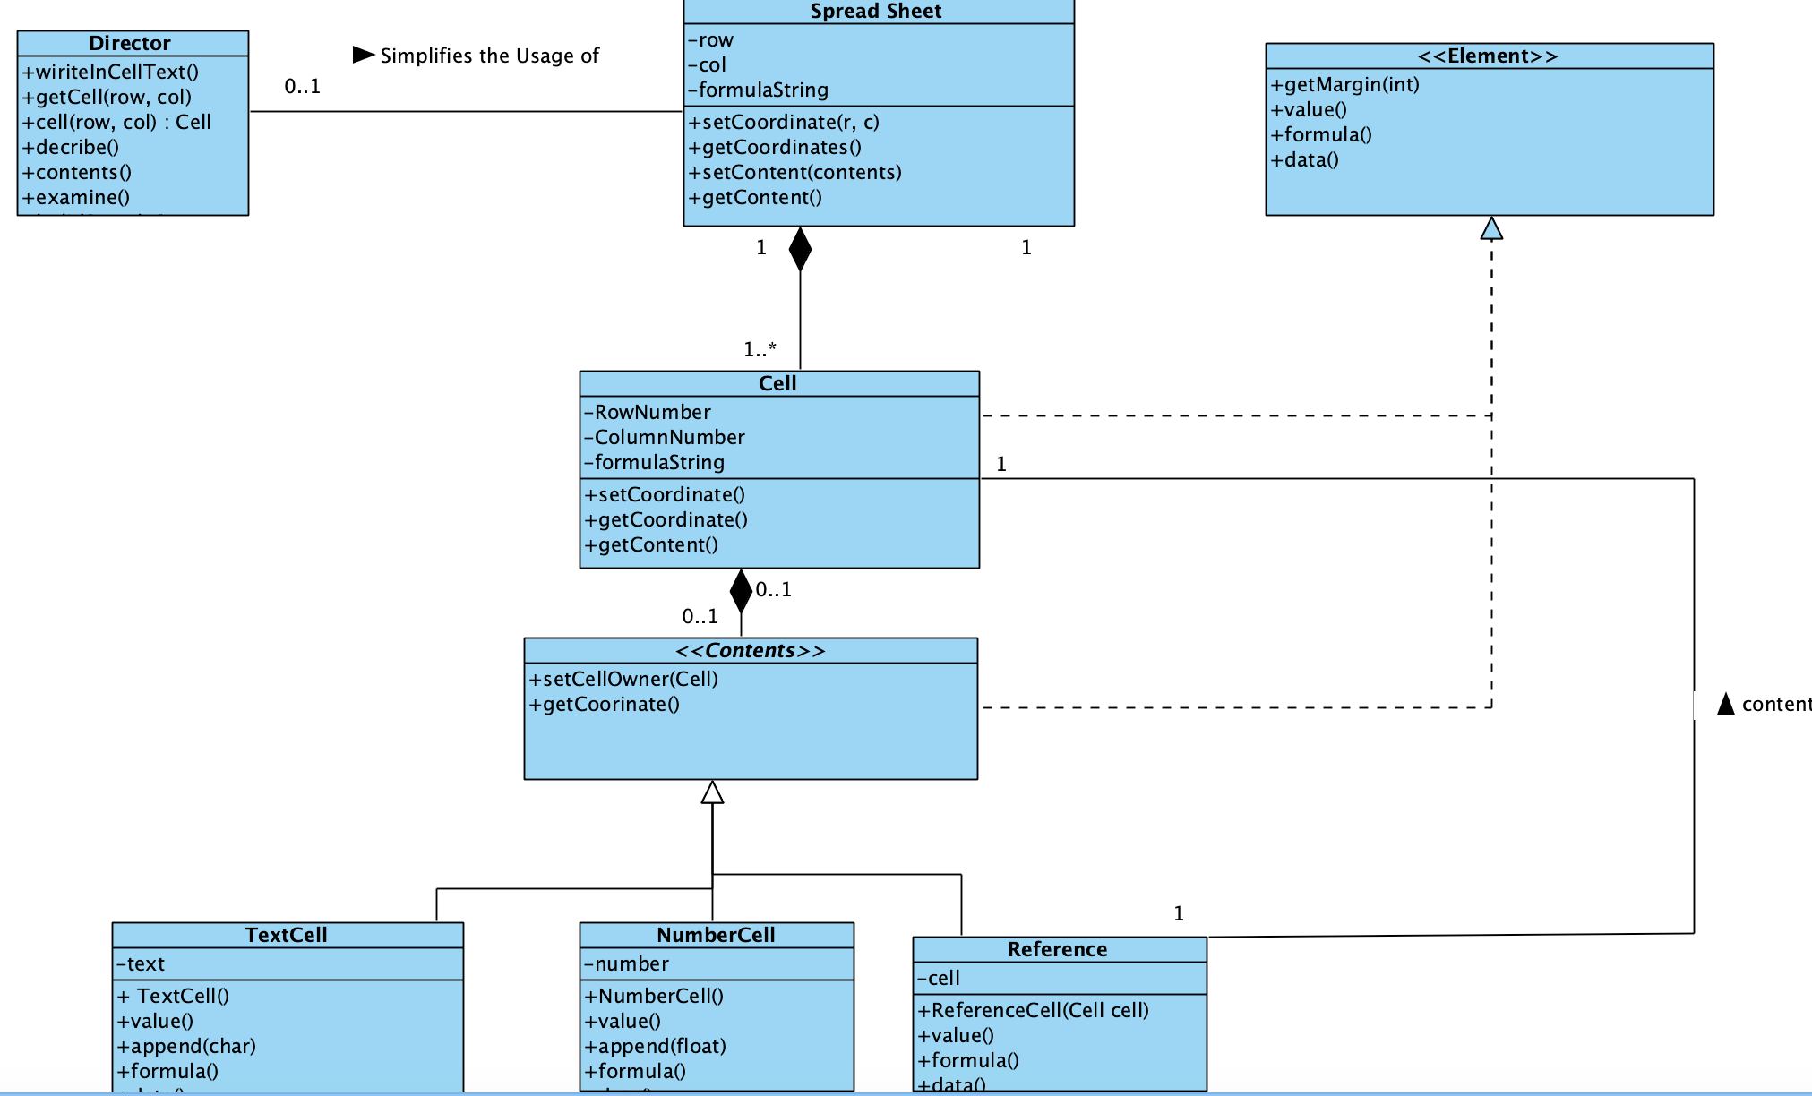

Class Structure

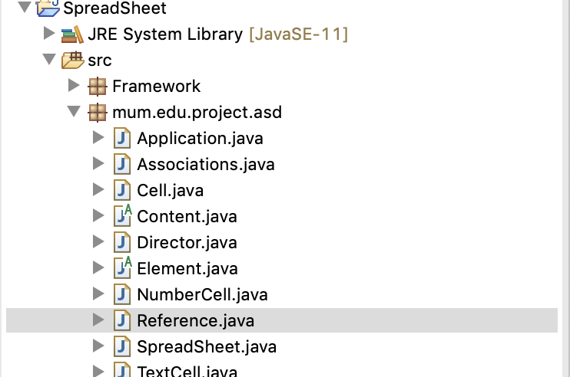

Code Sample

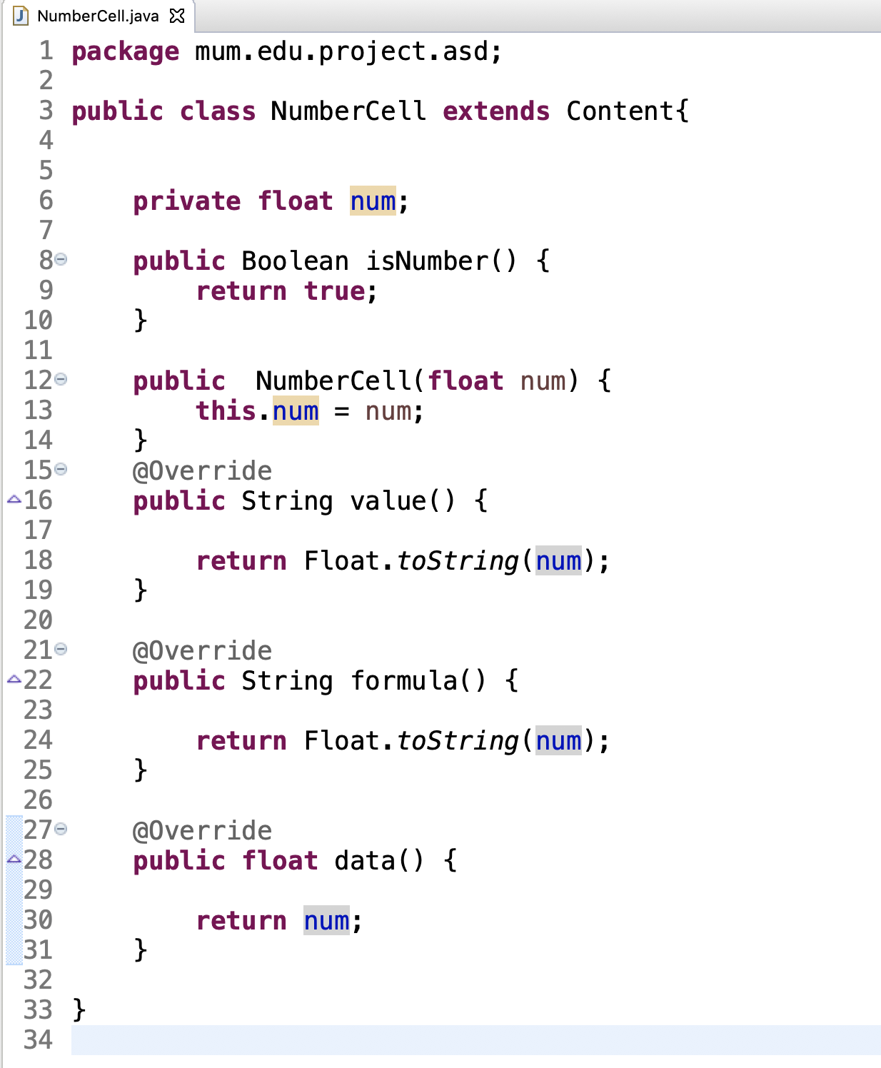

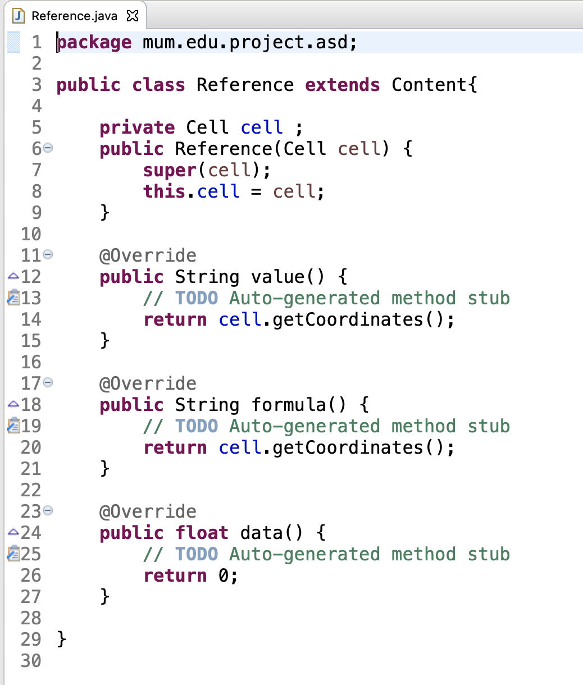

Sample Out out

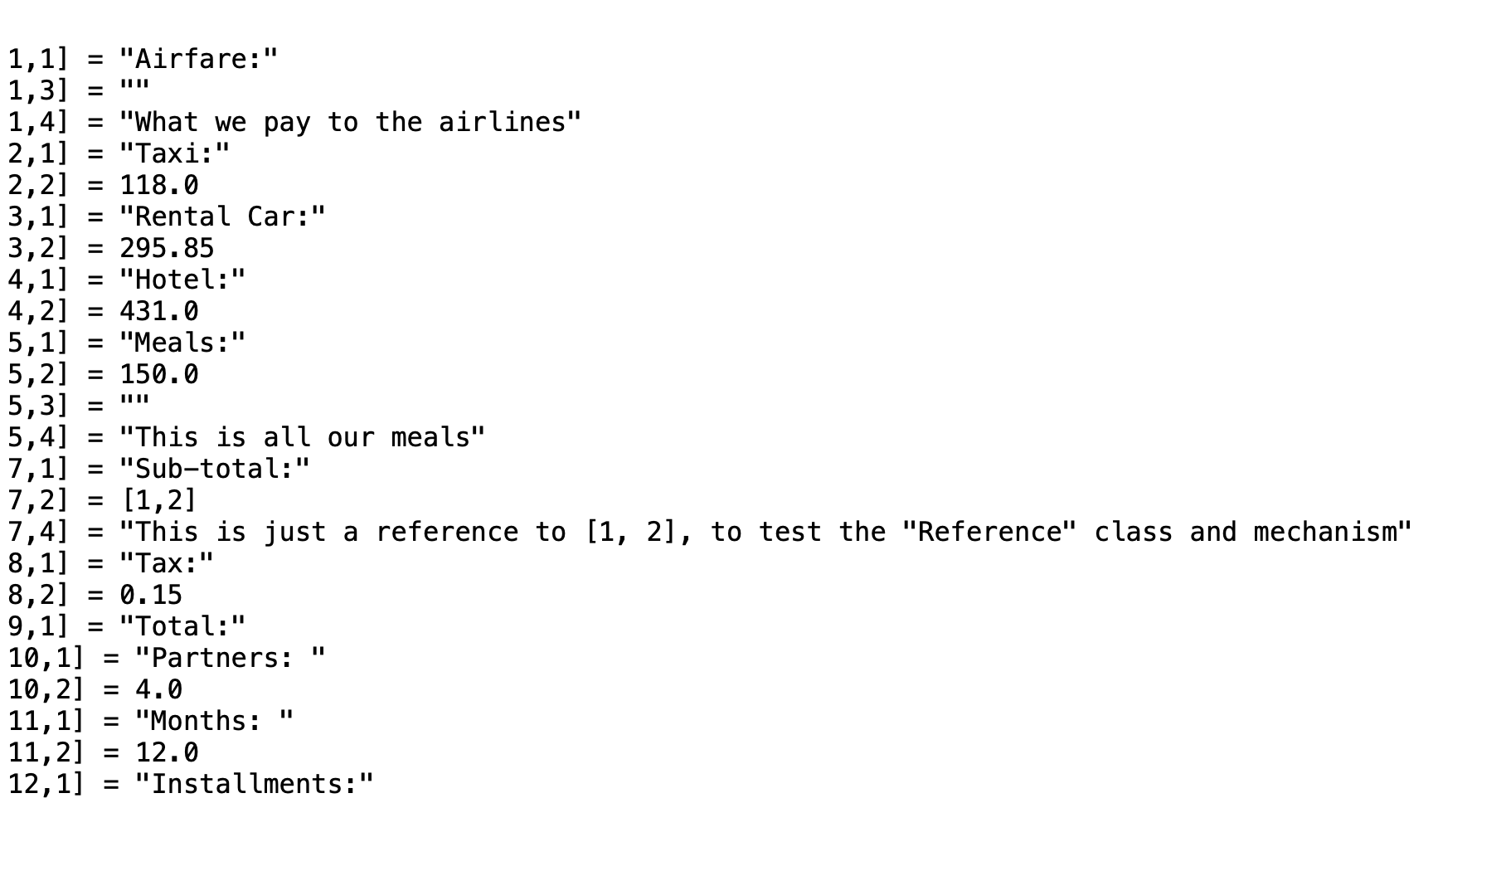

Sprint 3

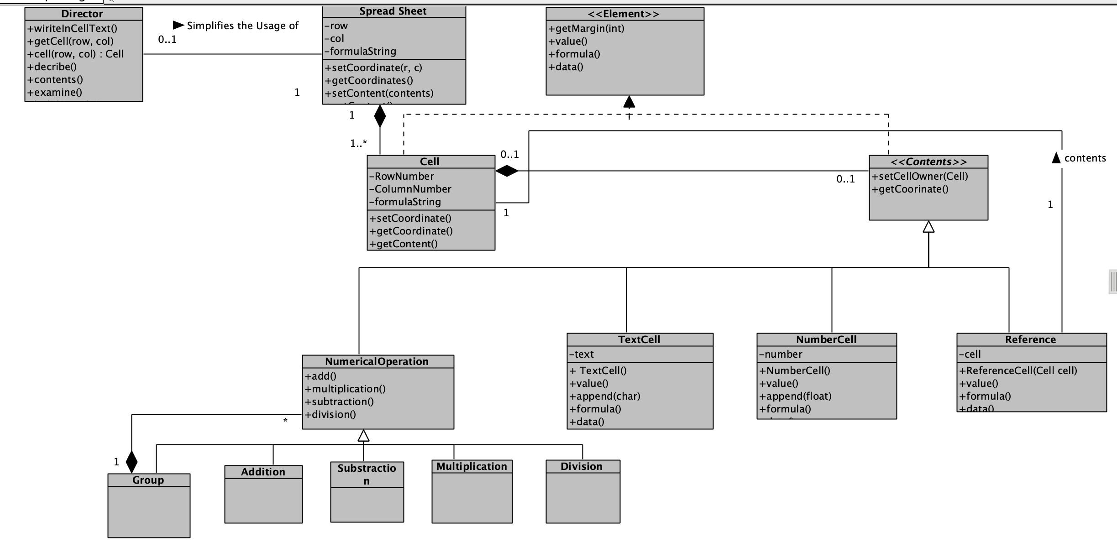

Sprint 4

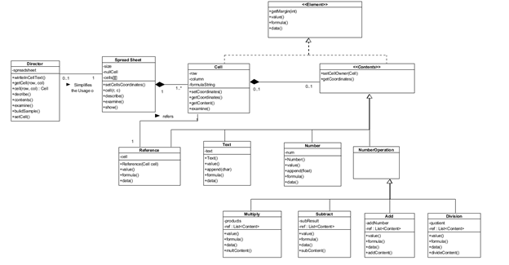

Sample source code:

Classes structure:

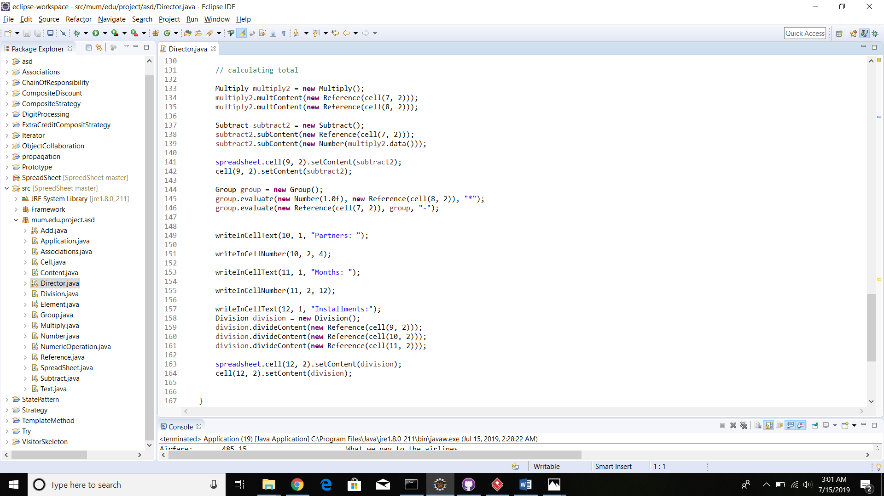

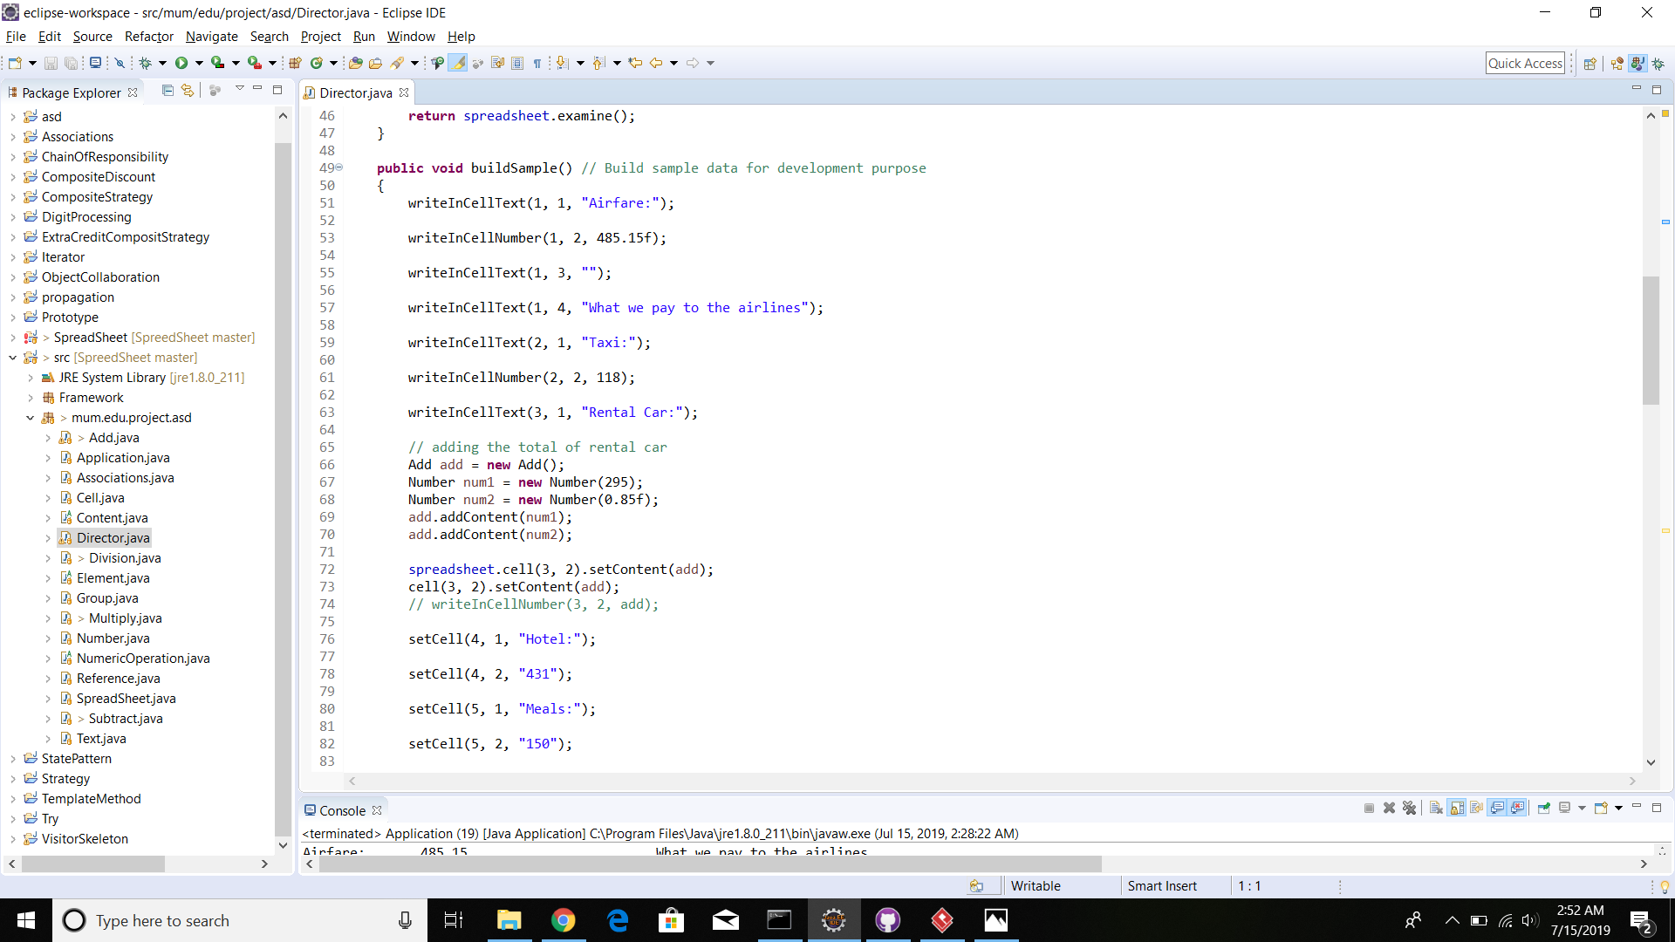

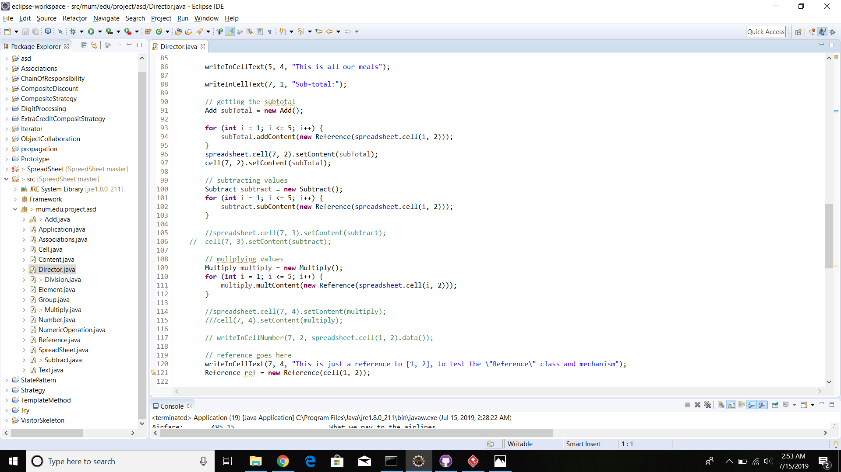

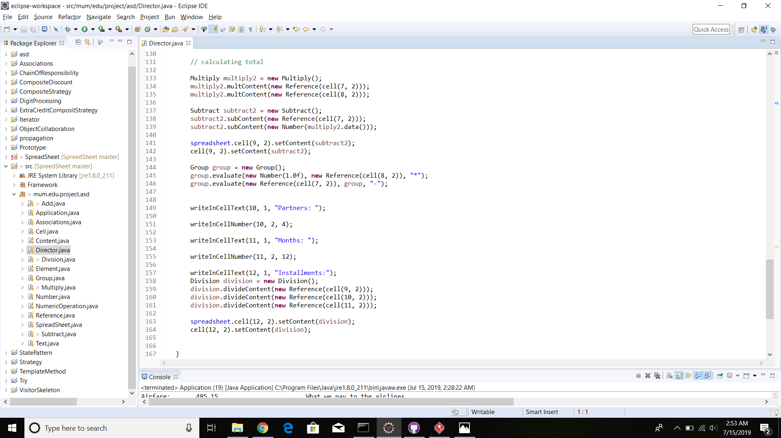

Output:

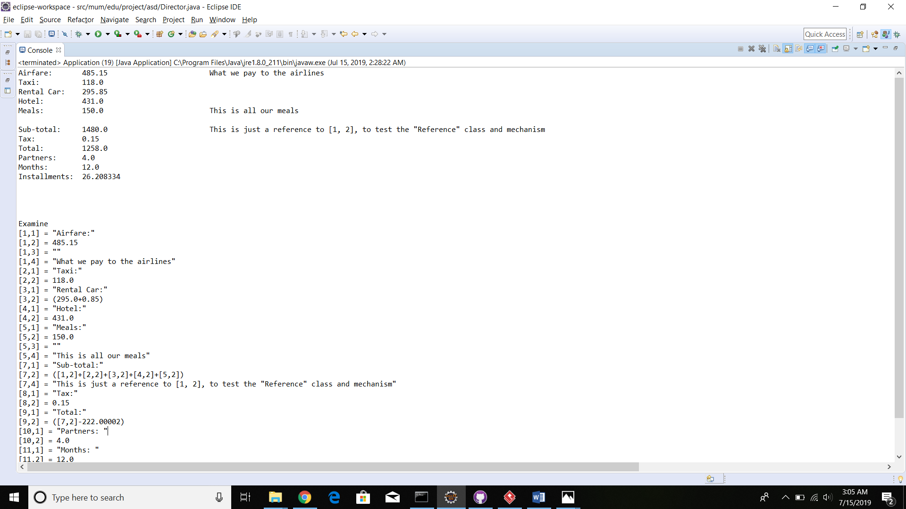

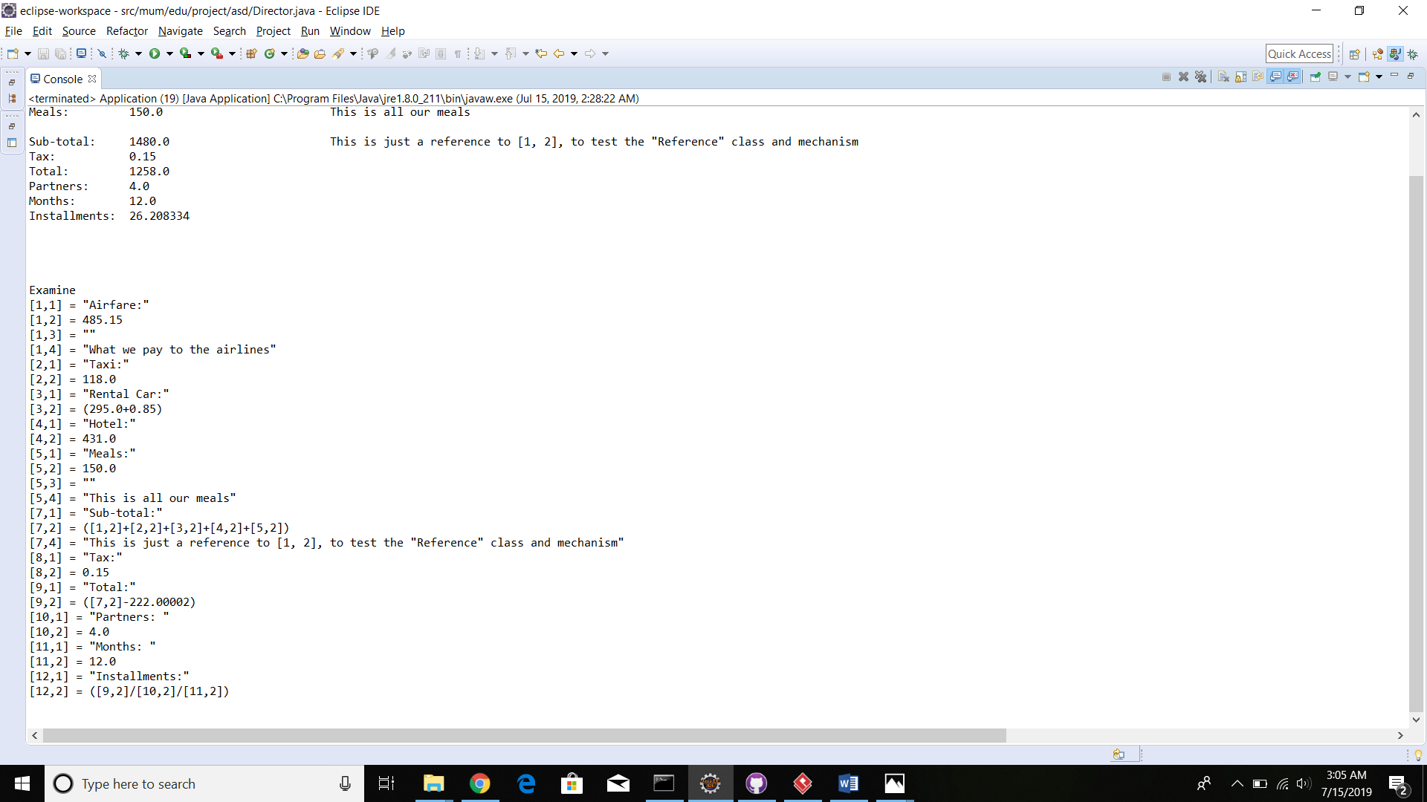

Sprint 5



Sample source code: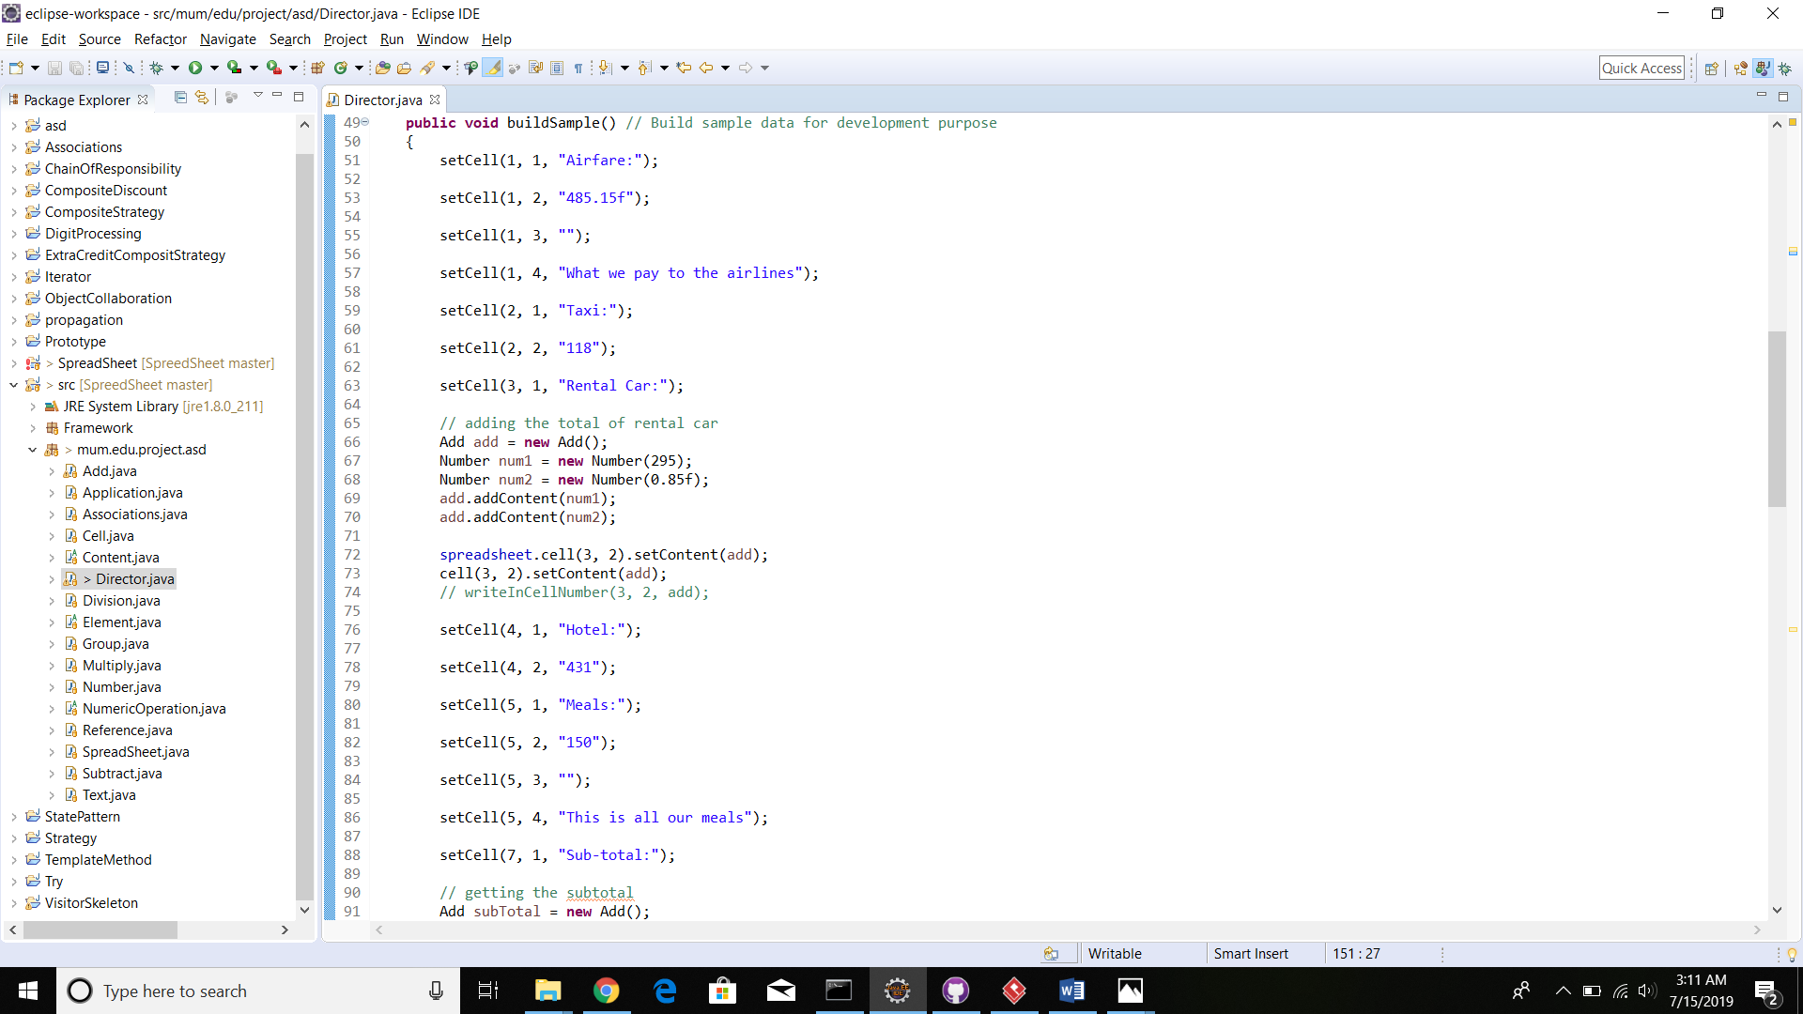

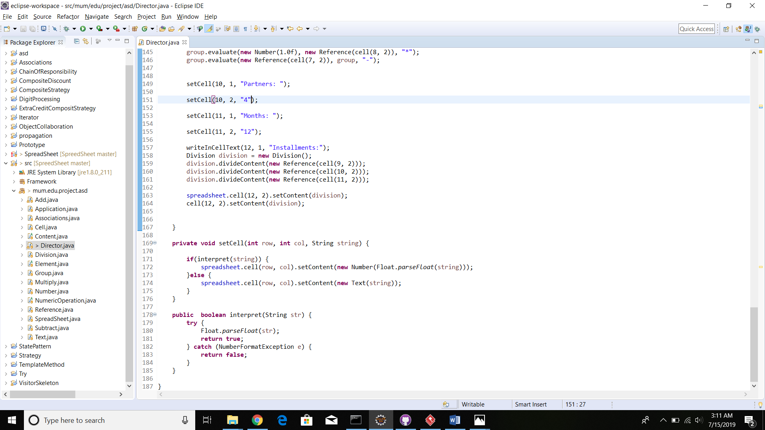

Output:





Sprint 6

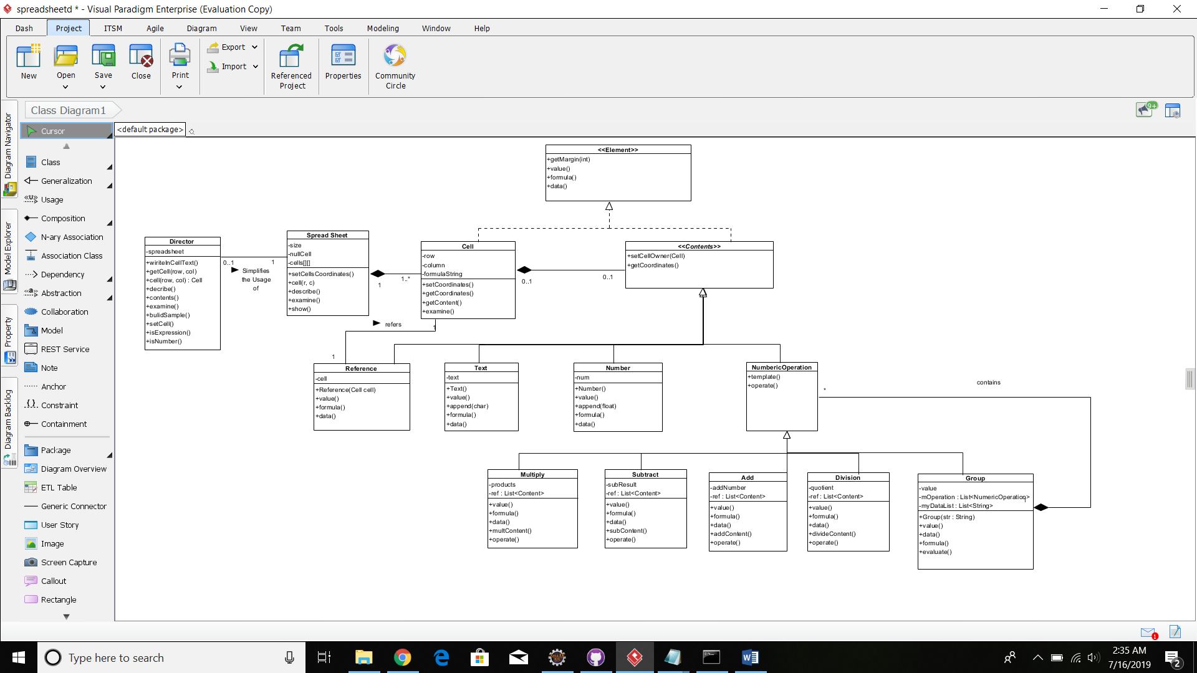

Sample code:

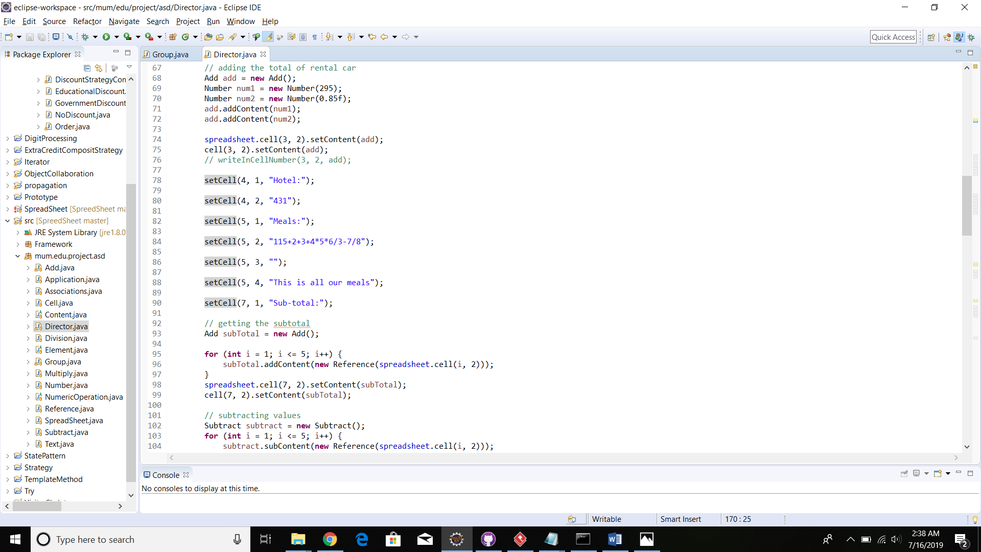

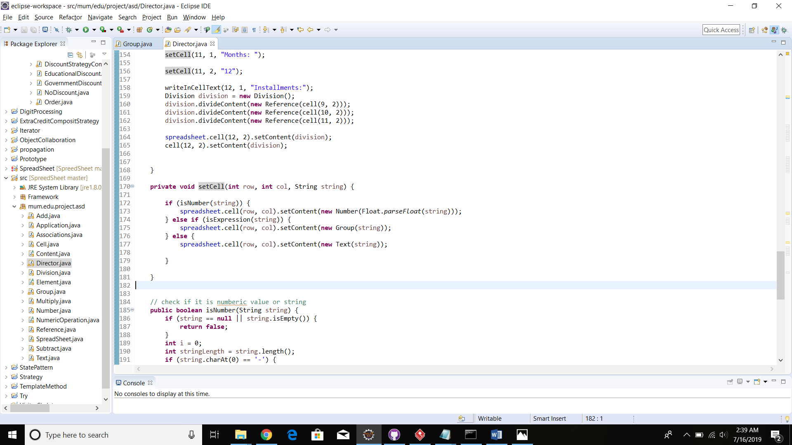

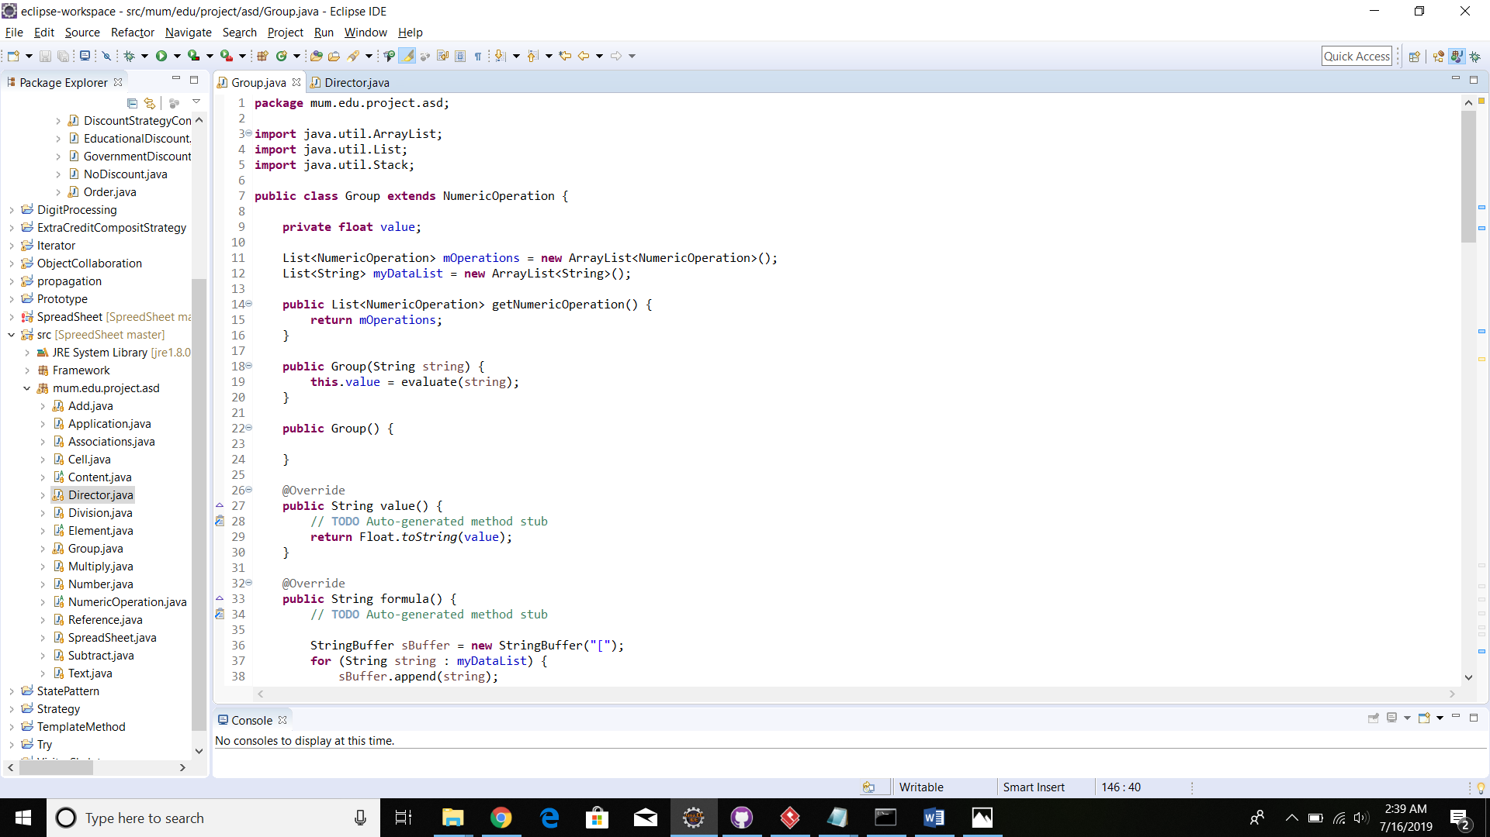

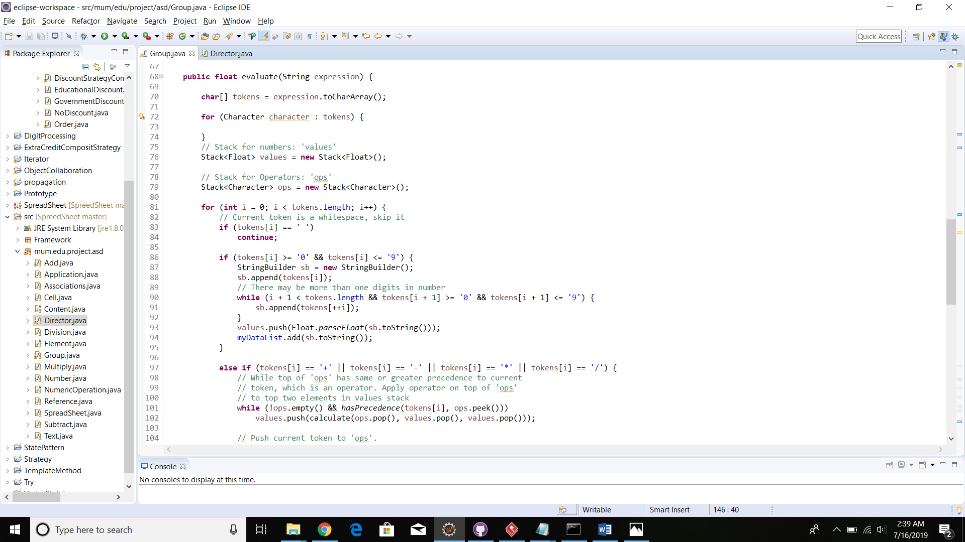

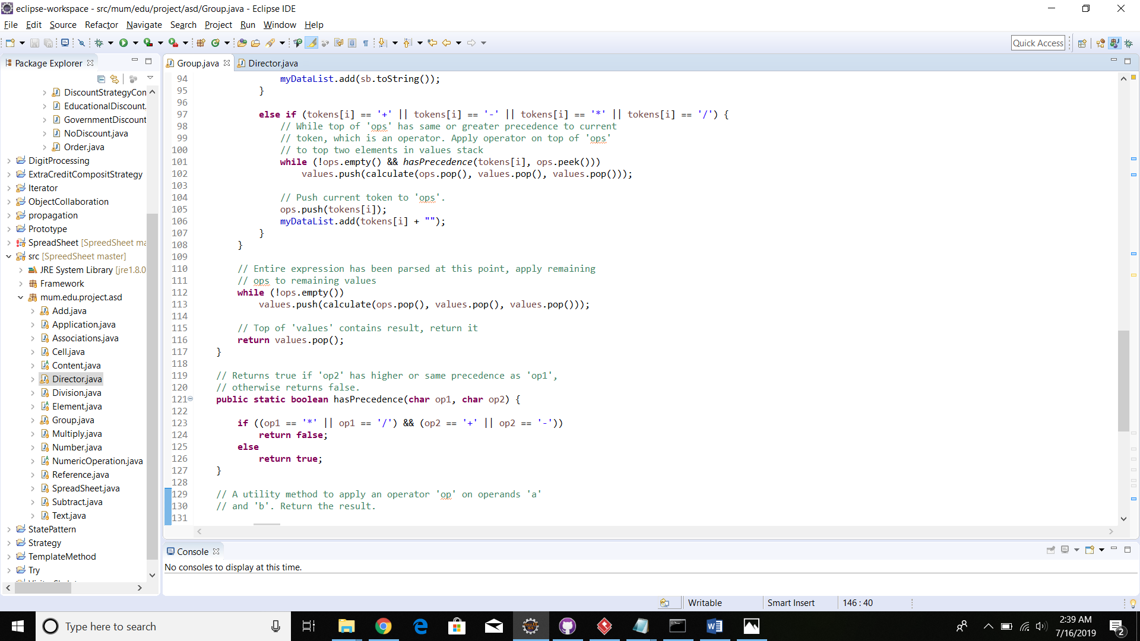

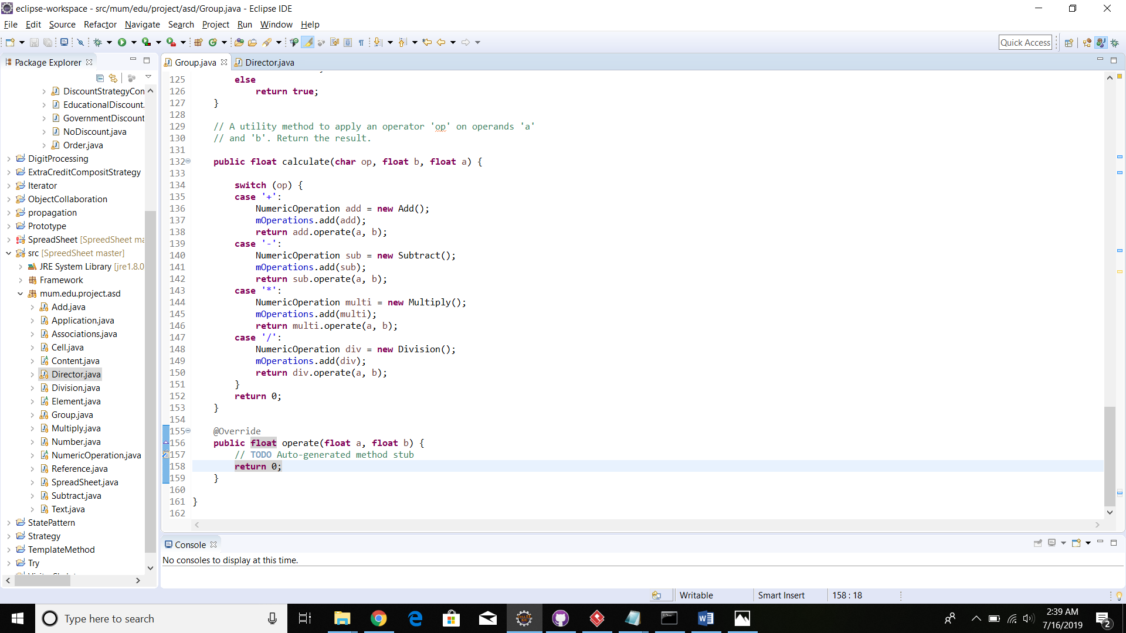

Output:

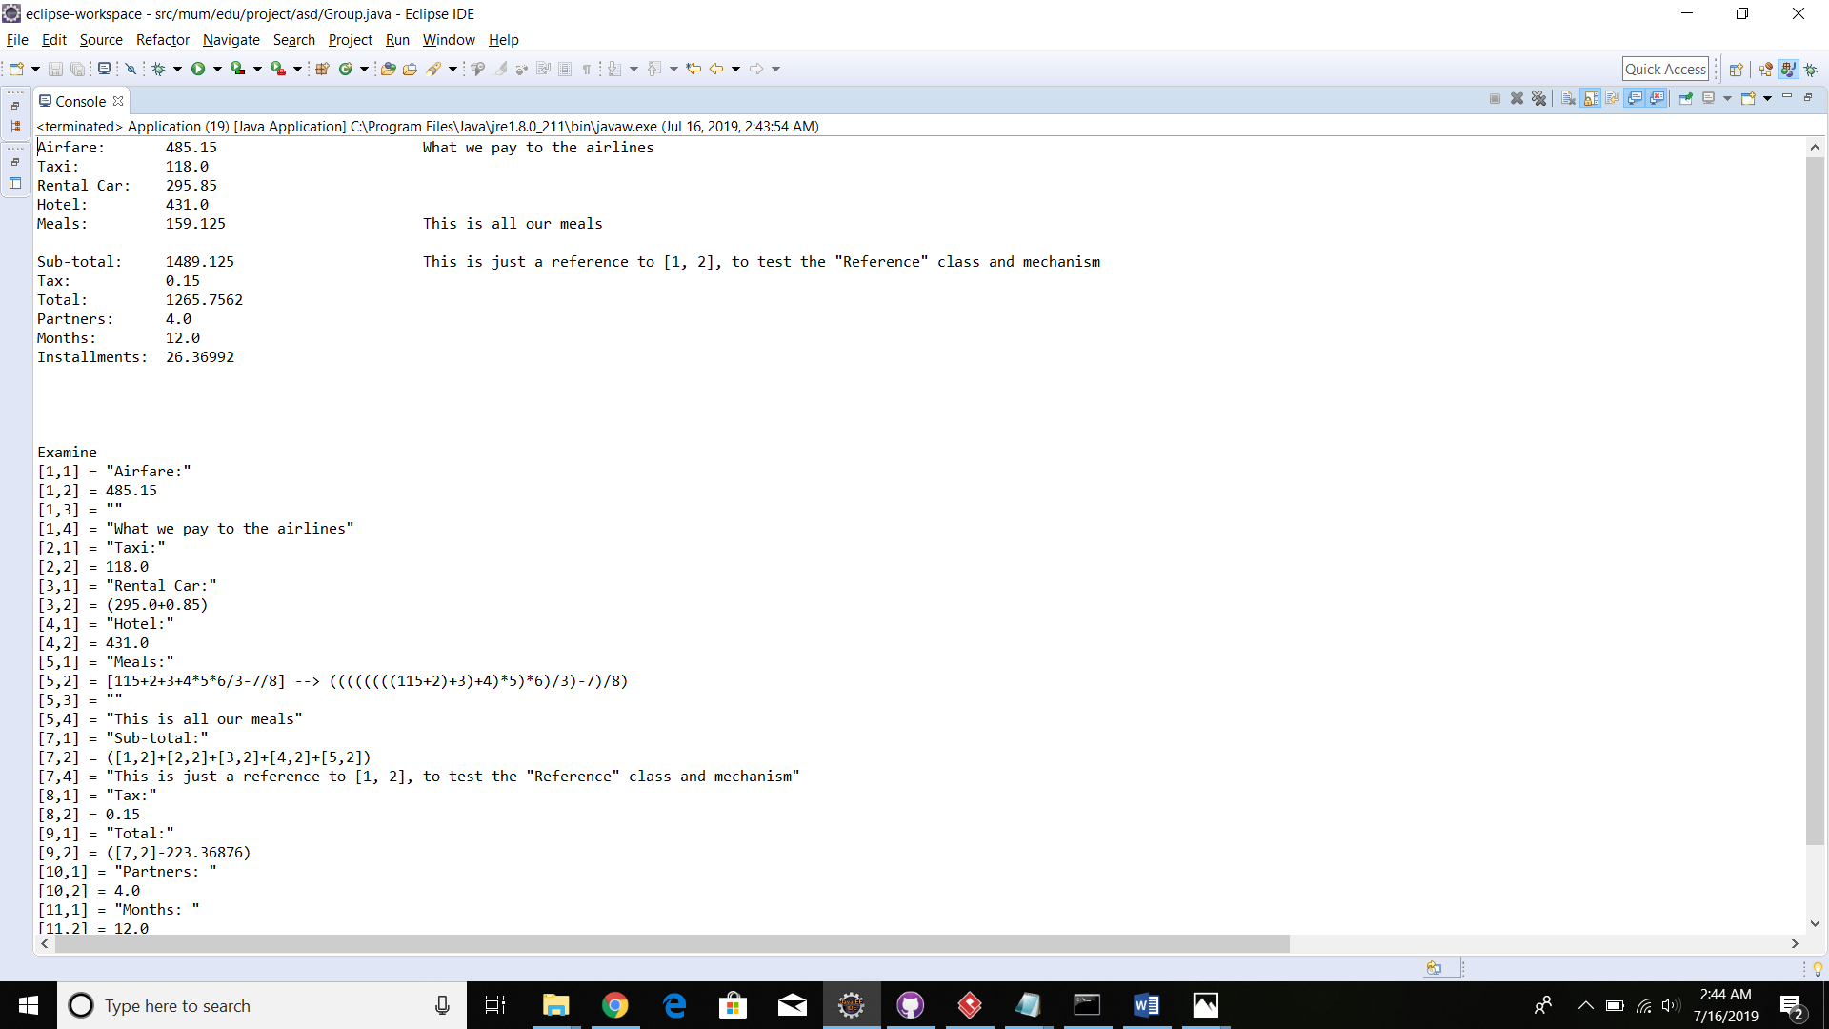

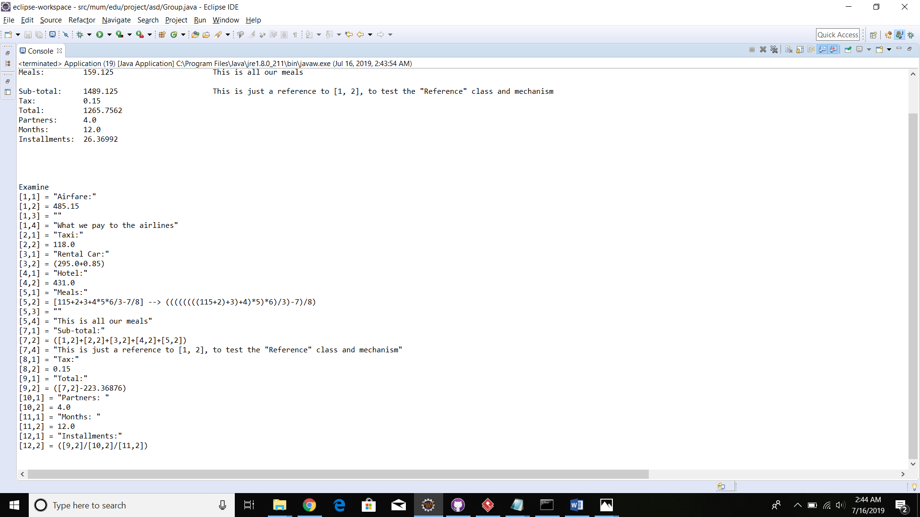

Sprint 7 and 8

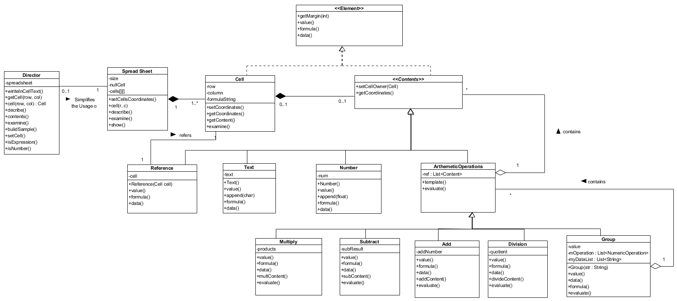

Sample code:

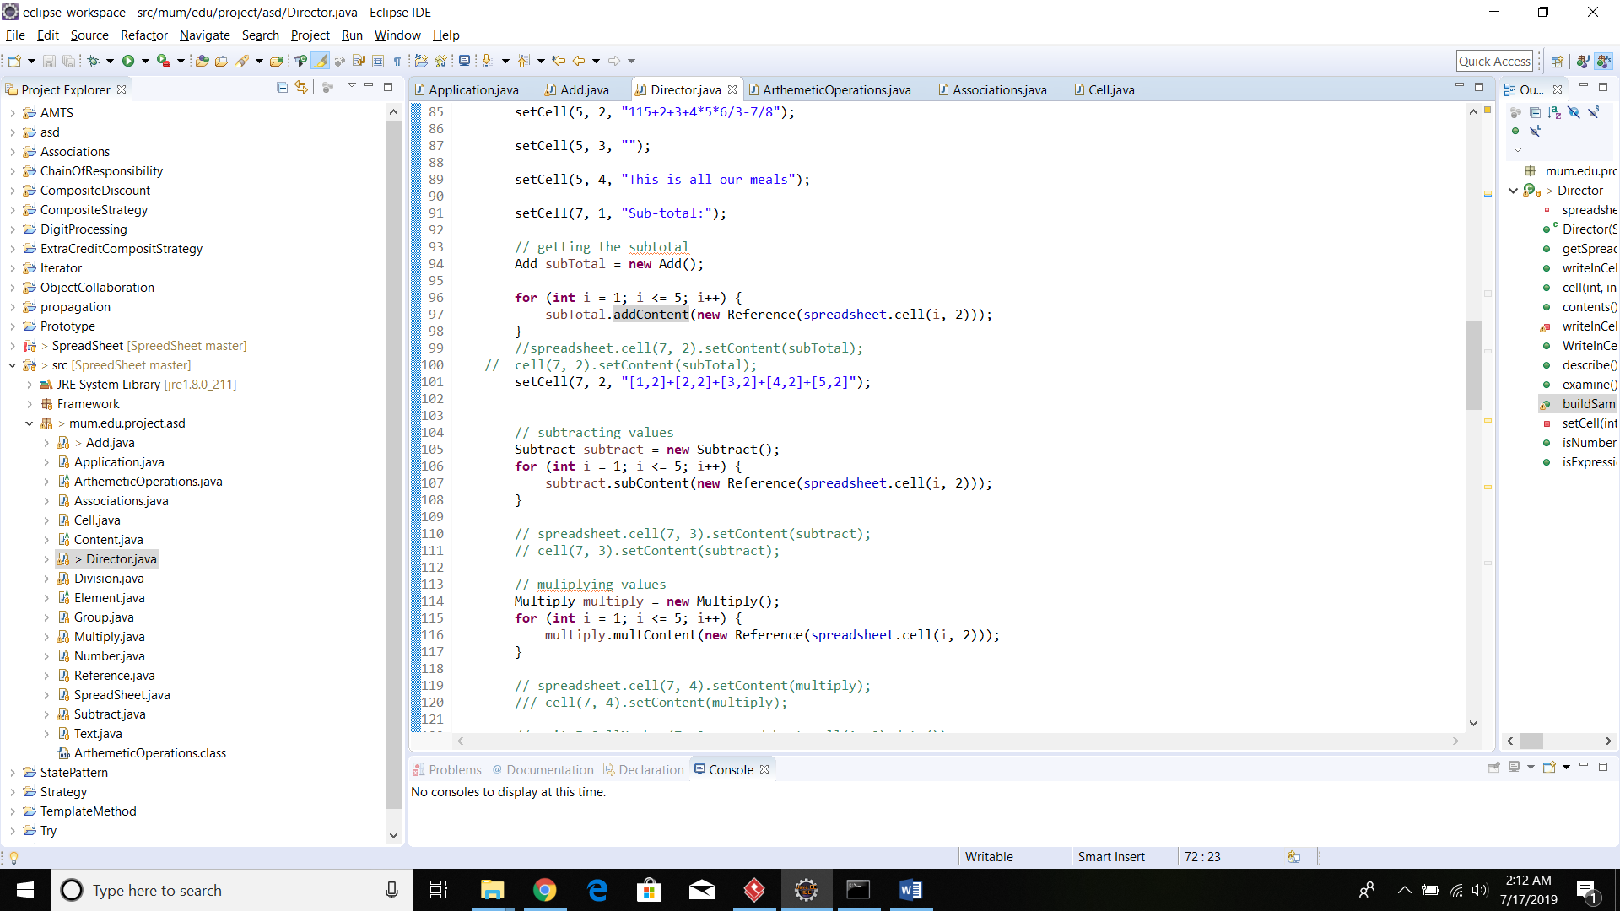

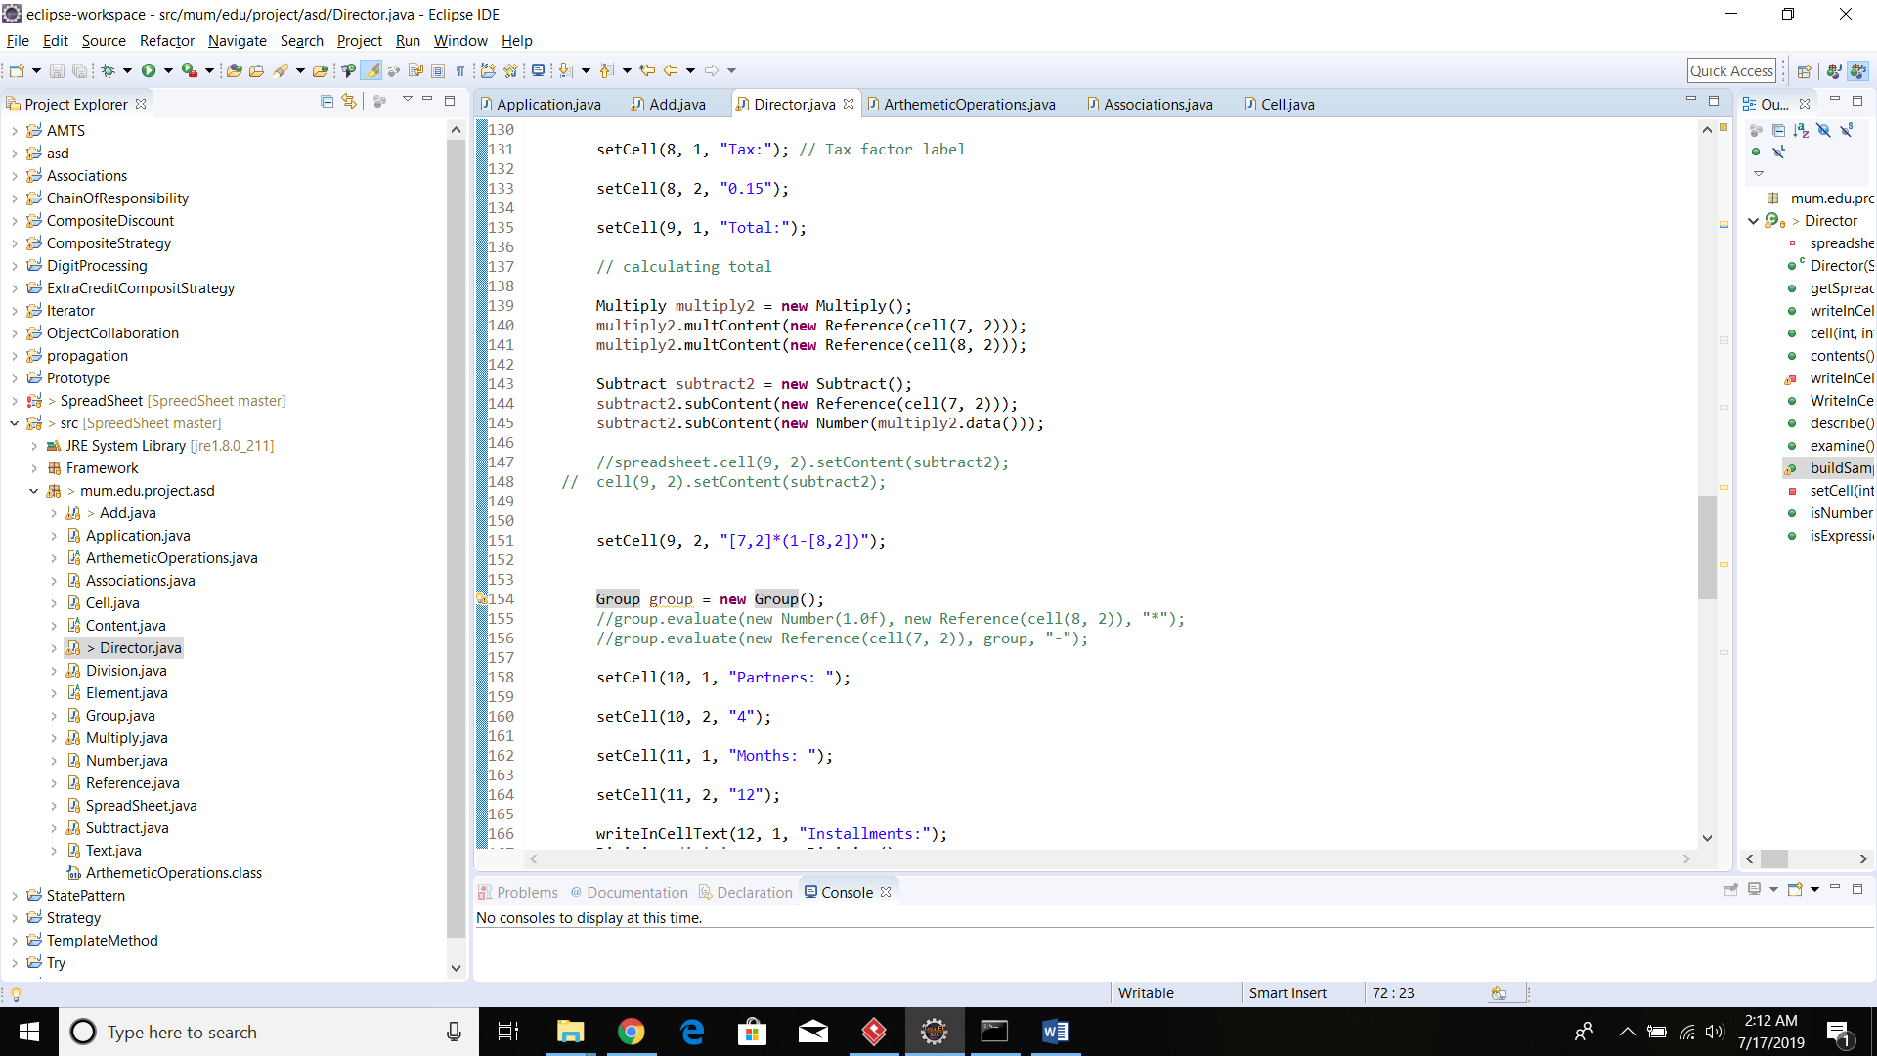

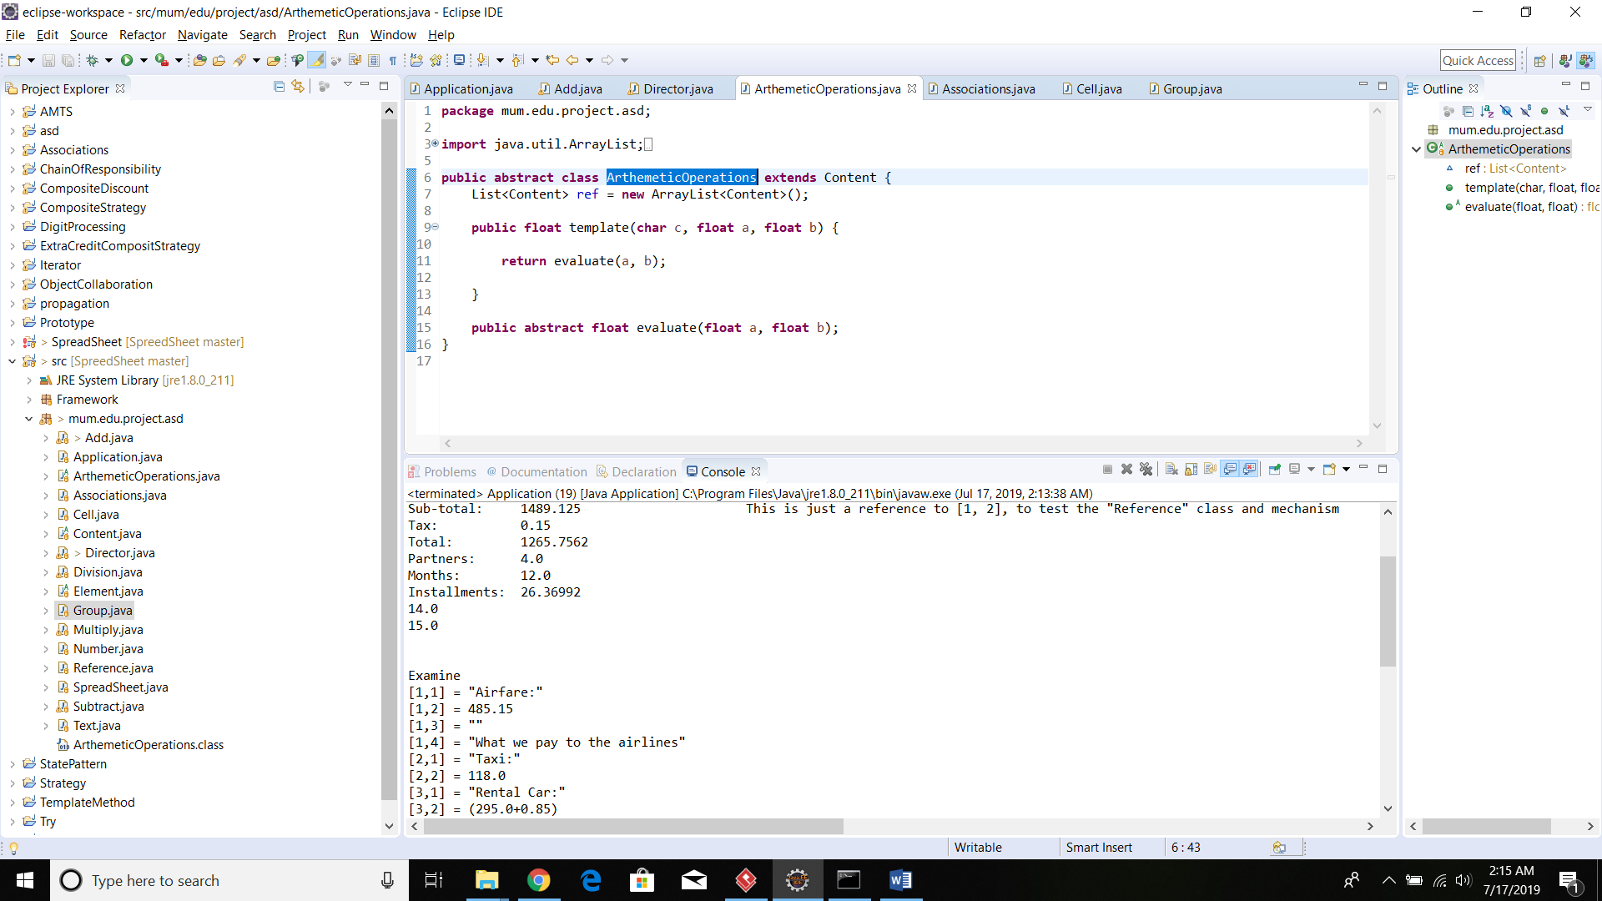

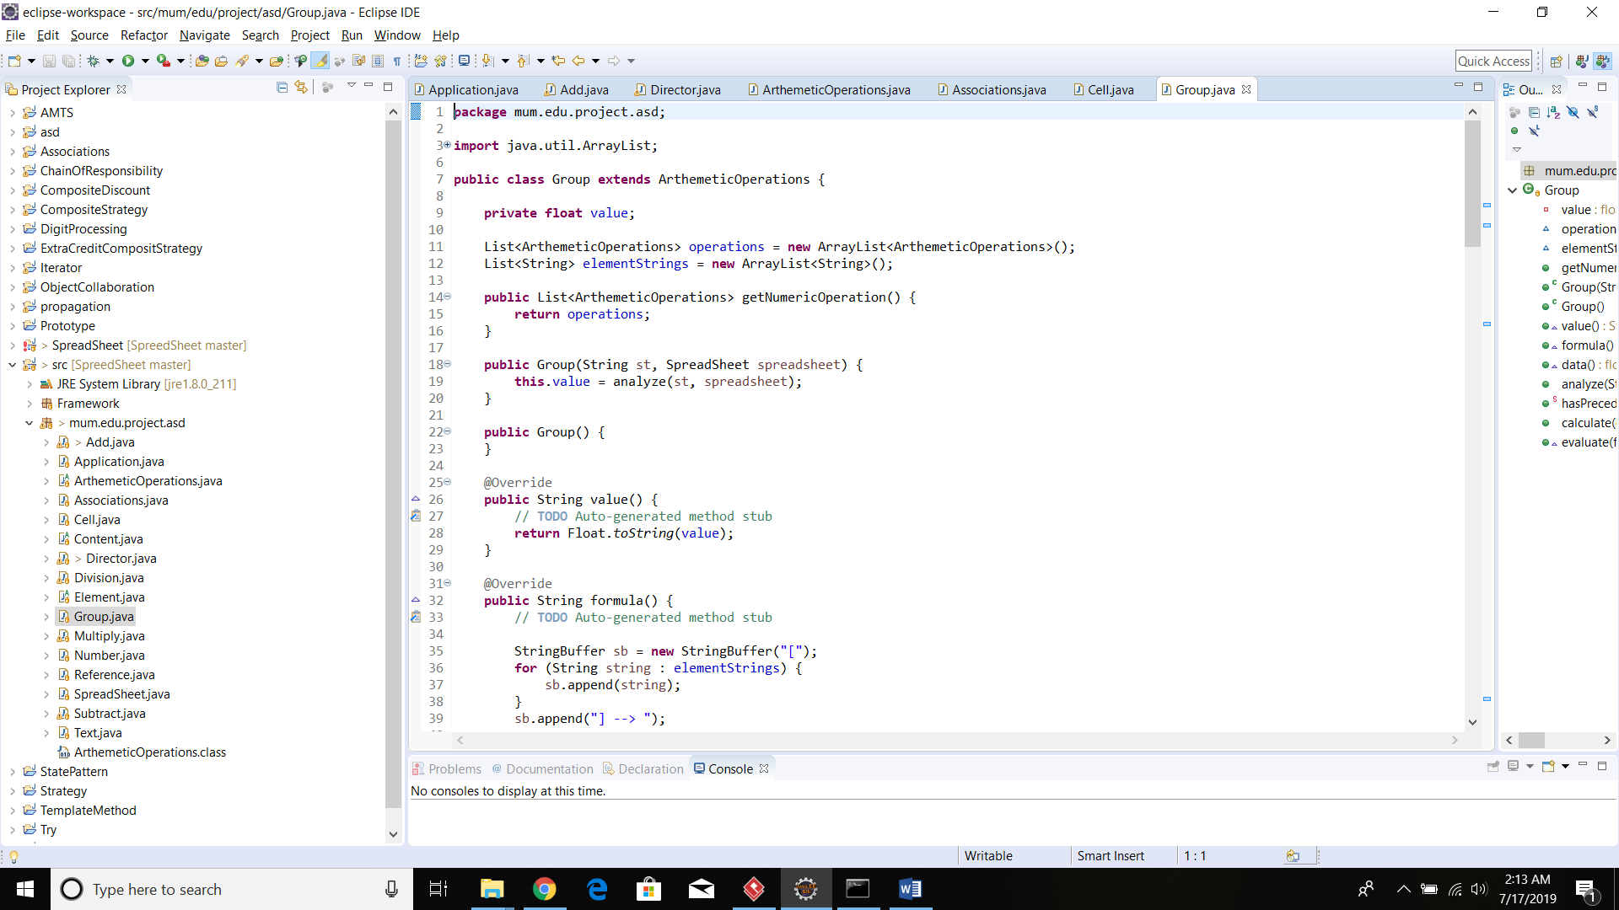

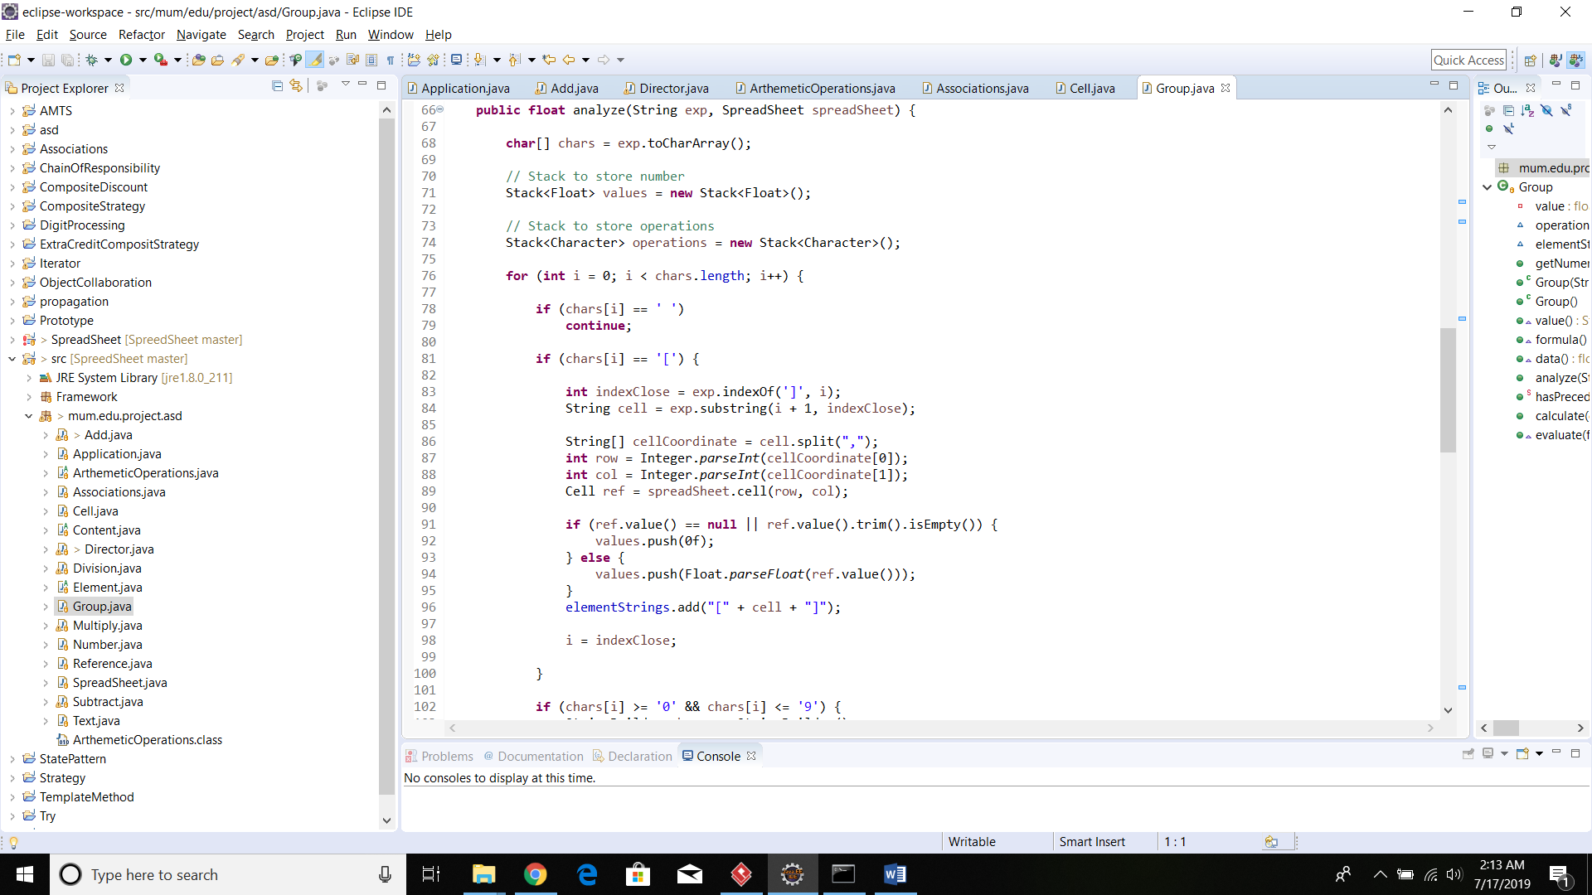

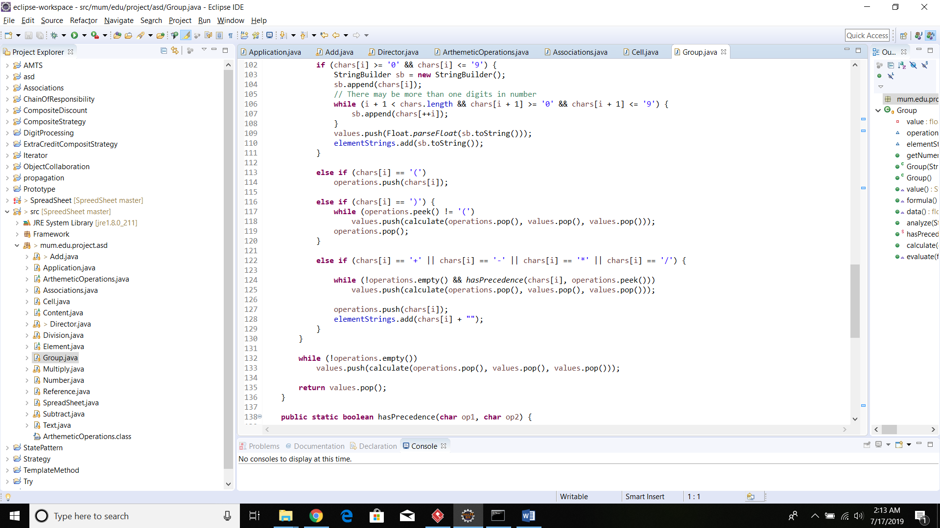

Output:

